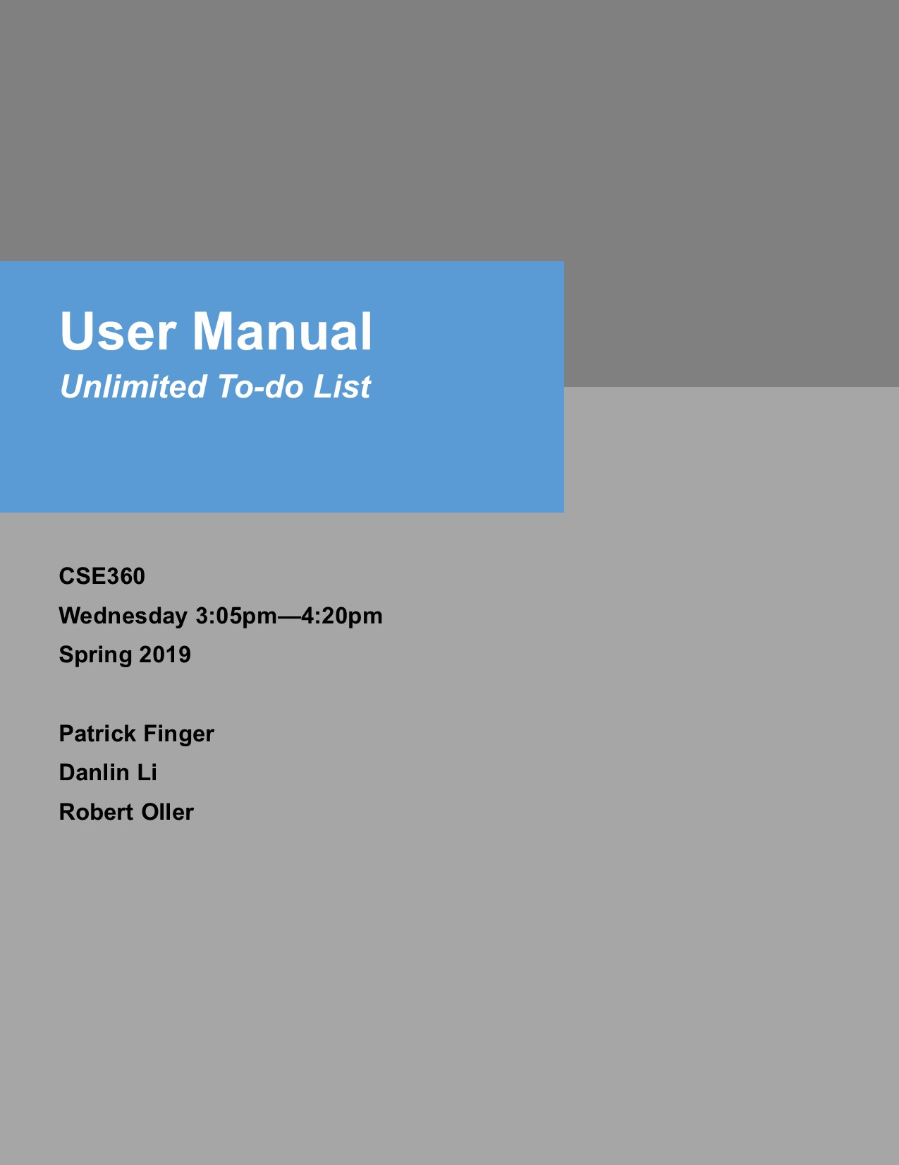





**1**

**2**

**3**

**Introduction…………………………………………………………………………….**

**Overview………………………………………………………………………………..**

**Installation……………………………………………………………………………...**

**Introduction //WIP**

In this user guide, we will be exploring how to use “Unlimited To-do List 2019­­”. First, an overview of To-do List will explore the basic functionalities of the program, including but not limited to what the program is capable of, what To-do List items can possess as properties, etc.

To begin use of the program, an installation guide will walk through the step-by-step process of installing the program on a PC, Mac, or Linux OS. After install is complete, the Getting Started page may be followed on getting familiarized with the program with initial usage. Once setup, the User Interface Overview goes over the user-friendly interface of the program, explaining how to navigate To-do List.

After becoming familiar with how to use To-do List, they may examine or glance at Example Runs section to see what does and does not work with To-do List. This section will go over how the user is expected to operate the program, and the errors which may occur if not properly used.

The Restarting section goes over how to properly save and load a To-do List when restarting the program. After which, Ending the Program section will explain how to safely exit the program.

**Overview //WIP**

The purpose of this program is for the user to have a simple way to prioritize items (tasks) in a To-do list. Each item has a description, priority number, due date, and status. The user has the option to add, remove, re-order, change the description, and display the properties of an item. Along with displaying an item, the user may also display the entirety of the To-do list itself. When the user wants to save or load a To-do list, they have the option to do so as well.

Regarding the items’ properties themselves, the description and priority number of an item must be unique. If the user wishes to enter an item with an existing priority number, the new item will take priority. The status of an item indicates whether the item is not started, in progress, or finished. When displaying the To-do list, each item will be listed in order of ascending priority with priority number, description, due date, and status listed under it.

What the user may *not* do is a number of things. These things include: loading an invalid file, adding an item with a non-sequential priority number, setting a due date in the past, adding or updating an item with an existing description, leaving fields blank when adding an item, etc.

**Installation //WIP**

PC: To install the program, download the .jar file and run the program by either double clicking or right clicking and selecting “open” in the dropdown menu.

Mac: To install the program, download the .jar file and run the program by either double clicking or right clicking and selecting “open” in the dropdown menu.

Linux: To install the program, download the .jar file and run the program by either double clicking or right clicking and selecting “open” in the dropdown menu.

**Termination //WIP**

To restart the program, all the added or edited description, priority number, due date, and status will be saved automatically. Then the program will stop running until it gets called again.

**Restarting //WIP**

To restart the program, all the added or edited description, priority number, due date, and status will be saved automatically. When the program has been started, all of the contents is restored exactly as before the program was terminated. The program will display the first event in the To-do List.